**Master Project Topics:**

**Research at the Biomass Transformation Lab (BTL)**

**Responsibles:**   
David Cannella (*PhotoBioCatalysis*)   
Biomass transformation Lab (BTL), École interfacultaire de Bioingénieurs (EIB)

**Emails**: [David.cannella@ulb.ac.be](mailto:David.cannella@ulb.ac.be)

**4 Subjects at PhotoBioCatalysis,** D.Cannella

1) Biosynthesis of green plant stimulants and biopesticides for AgroBiotech

2) Biomass Transformation into BioPLAstic and Biofuels for Biorefineries

3) Enzymes evolution and engineering for biocatalysis&bioeconomy ([Molecular biology – Biochemistry)](https://www.photobiocatalysis.org/master-thesis)

4) [Nano-Cellulose Biomaterials production](https://www.photobiocatalysis.org/master-thesis) – from Biomass to smart materials

**PhotoBiocatalysis Unit BioCat- D. Cannella**[**www.photobiocatalysis.org**](http://www.photobiocatalysis.org)

**Projects description:**

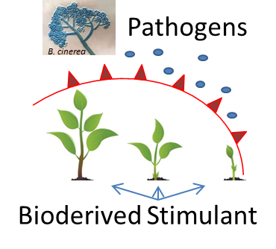**1) Biosynthesis of green plant stimulants and biopesticides for AgroBiotech  
Plant cell wall degradative enzymes** (CWDEs) are the arsenal used by pathogenic microorganisms (fungi) during their attack to plants. They represent a growing and continuous threats to crops and food production.  Us such the student will have to apply fungal-born enzymatic cocktail and measure the entity of plant cell wall degradation ex-vivo or in-vivo of plant subjected to a/biotic stresses. Key genes expressions as marker of plant immune system (molecular biology tech.), will be assessed so to predict the severity of the stresses applied. Moreover the plants will have to be evaluated to their increased or decreased susceptibility to pathogenic attack measuring secondary metabolites (HPLC and analytical chem techs), therefore hydroponic and standard cultivations will be studied (basic plant biology techs). The student will work together with an international team made of senior scientists and PhD students. The thesis will helps formulating general theories and trends of environmental and sustainability concerns for crops "bio"-productions, environmental bioremediations etc ...).

**Duration:** 8-9 months minimum or more  
**Techniques**: Plant cultivations and physiology, hydroponic, plant molecular biology, RT-PCR, Microarray, RNA-seq, HPLC, enzymes.  
**Supervision level**: D.Cannella, weekly email at [dcannell@ulb.ac.be](mailto:dcannell@ulb.ac.be)

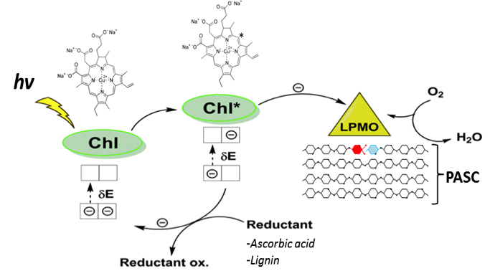**2) Enzymes evolution and engineering for photobiocatalysis&bioeconomy** ([Molecular biology – Biochemistry)](https://www.photobiocatalysis.org/master-thesis).

Worldwide the research in photobiocatalysis is focusing on applications of redox enzymes for the development of biorefineries based on lignocellulose resources. **Fungi** represents the natural sources of photo-excitable unique enzymes: LPMO, Laccase, SOD, peroxidases and new more are discovered constantly. Particular attention is dedicated at maximizing their activities which for redox enzymes means better electron donation, and research on LPMO enzymes elucidated some of its main characteristics, and possible way for its application.  In this project the student will investigate how to evolve and engineer Biomass-Active enzymes to increase their photocatalytic performances, substrate preferences stability and more. Also, will investigate stable heterologous expression, host selection to resemble industrial applications, purification and activity tests.

**Duration:** 6-9 months minimum or more  
**Techniques**: Molecular biology, plasmid assembly, PCR, RT-PCR, fungal-yeast-bacterial culturing, photo-biology, HPLC, purification via FPLC, rudiment of bioinformatics, structural biochemistry.  
**Supervision level**: D.Cannella, weekly email at [dcannell@ulb.ac.be](mailto:dcannell@ulb.ac.be)

**3) Biomass Transformation into BioPLAstic and Biofuels for Biorefineries**

The transformation of biomass into biofuels, bioplastics and bio-chemicals is today needed and it is already a robust reality at industrial scale. The today Bio-Engineers involved in circular economy is demanded to master the bio-transformation processes. In this project the student will have to transform the lignocellulosic biomass (or other alternatives) into a chosen commodity of her/his interest among: BioPLAstic, that is a Polymerized Lactic Acid molecule (PLA) to substitute petrol derived; BioFuels, in form of bio-ethanol; or BioChemicals in form of oligosaccharides for food implementation. The novelty of the project is guaranteed by the implementation of PhotoBiocatalysis processes via introducing physicochemical stimuli to the classical settings for carrying the enzymatic hydrolysis and fermentation of lignocellulose. The students will have to find the optimal parameters to increase the digestion of lignocellulose biomass and its consequent fermentation. The fine tuning of the settings will be carried from flask to progressively scale up to 2-20 lit volume pilot bioreactors. Finally fermentation of the biomass hydrolysate into a final desirable product will be performed using dedicated yeast and lactobacillus strains (bioethanol or bio-lactic acid for PLA or glycerol).

**Duration:** 6-9 months  
**Techniques**: bioreactor management, assembly, and design; photo-bio-catalysis, biomass chemistry, applied enzymology, HPLC, HPAEC-DA, fungal-yeast-bacterial culturing.   
**Supervision level**: D.Cannella, weekly email at [dcannell@ulb.ac.be](mailto:dcannell@ulb.ac.be)

**4)** [**Nano-Cellulose Biomaterials production**](https://www.photobiocatalysis.org/master-thesis) **– from Biomass to smart materials**

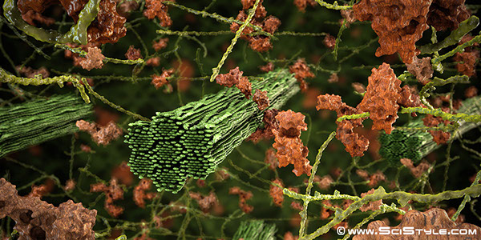Biomaterials are getting great interests for their versatile uses as composite materials, biomedical - hygiene products, food industry, packaging and smart-screens for TV and cellphones, and more. Nano-Cellulose and Nano-Fibrils (CNC and CNF) are considered the major and more applicable of these smart biomaterials, therefore research on bio-production and greener extraction is very active. In this project the student will have to investigate the transformation of raw biomasses from local (Bruxelloise) woods into NanoCellulose biomaterials using a green approach represented by enzymes to supplement the classic chemical-based processes. Moreover, characterization of physical property via microscopy, X-ray, FT-IR and more are envisioned. The student will have the choice to also fabricate the biomaterial for specific purpose of her/his preference, demonstrate the functionality in form of a small prototype: ex. Touch-sensible for Smart-screen, biocompatibility for use as patches, or enzymatic immobilization for bio-packaging.

**Duration:** 6-9 months  
**Techniques**: chemical-biochemical characterization of wood; reactor assembly for CNC production; TEM-SEM microscopy, X-ray, FT-IR, TCA etc. applied enzymology, HPLC.   
**Supervision level**: D.Cannella, weekly email at [dcannell@ulb.ac.be](mailto:dcannell@ulb.ac.be)