**Master Project Topics:**

**Research at the Biomass Transformation Lab (BTL)**

**Responsibles:**   
David Cannella (*PhotoBioCatalysis*) and Amin Shavandi (*BioMatter*)  
Biomass transformation Lab (BTL), École interfacultaire de Bioingénieurs (EIB)

**Emails**: [David.cannella@ulb.ac.be](mailto:David.cannella@ulb.ac.be) **or** [Amin.shavandi@ulb.ac.be](mailto:Amin.shavandi@ulb.ac.be)

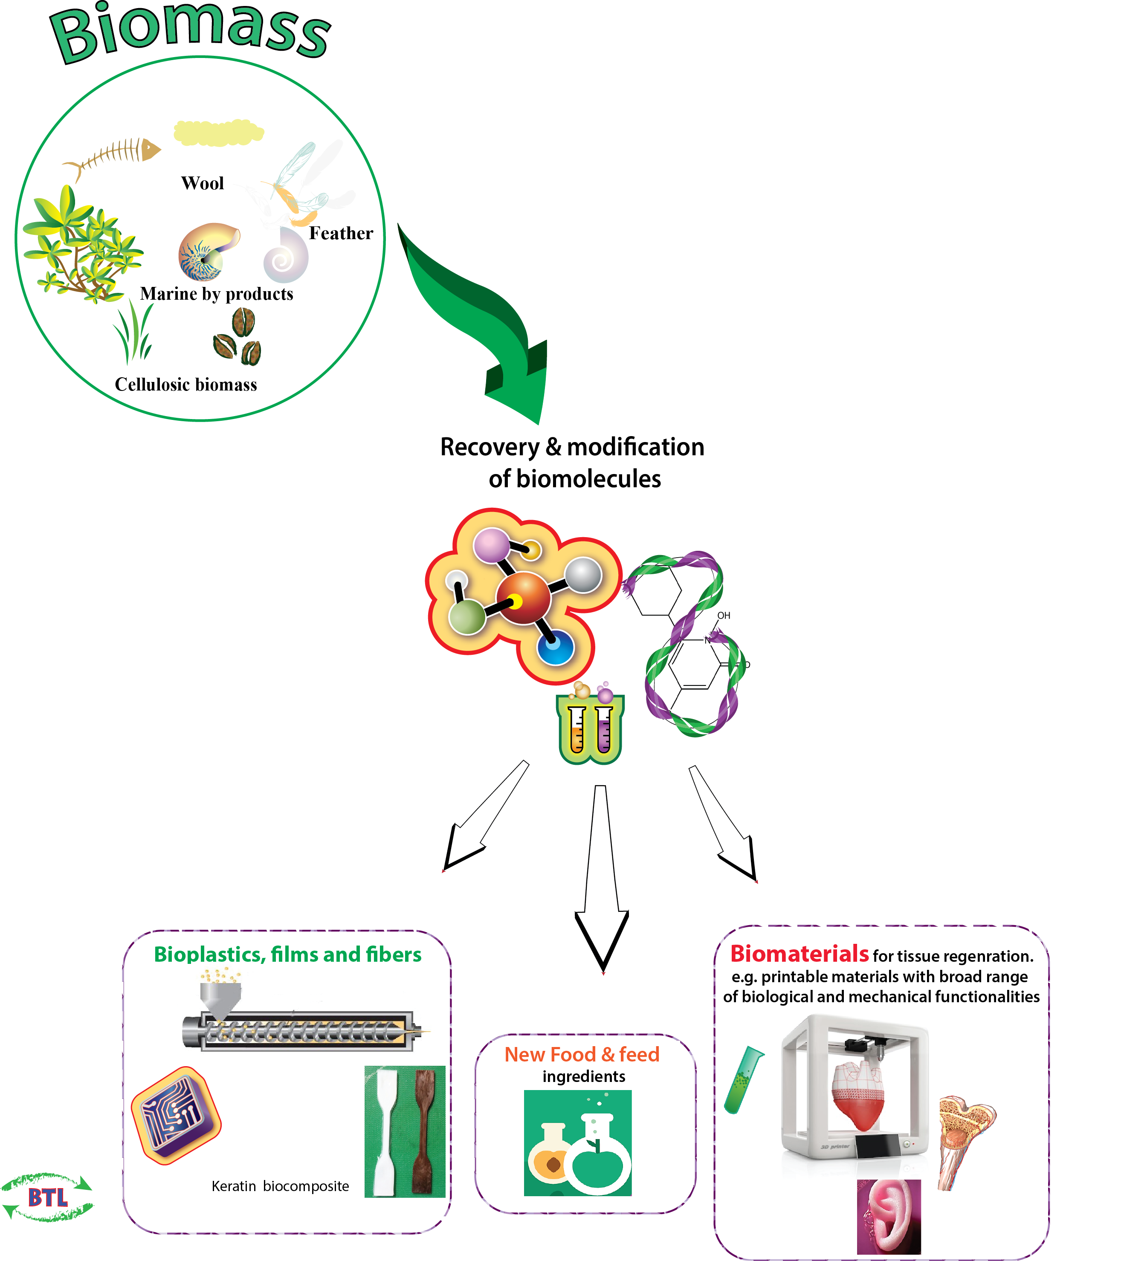**4 Subjects at PhotoBioCatalysis,** D.Cannella **4 subjects at BioMatter,** A.Shavandi

1. **Antibacterial hydrogel with potential wound healing applications: The effect of Tannic acid on hydrogel gelation and adhesive properties.**  
  
2. **Investigation of the effect of tannic acid concentration and treatment time on the physicochemical and biological properties of hydrogels reinforced by cellulose nanocrystal**.  
  
3. Isolation and physicochemical properties of protein from insect farm side stream as a new source of bioactive molecules  
  
4. **Collagen extraction and characterization from mussel byssus and possible application as a wound healing patch.**

1) Biosynthesis of green plant stimulants and biopesticides for AgroBiotech

2) Biomass Transformation into BioPLAstic and Biofuels for Biorefineries

3) Enzymes evolution and engineering for biocatalysis&bioeconomy ([Molecular biology – Biochemistry)](https://www.photobiocatalysis.org/master-thesis)

4) [Nano-Cellulose Biomaterials production](https://www.photobiocatalysis.org/master-thesis) – from Biomass to smart materials

Scheme 1: Research activities at the Biomass Transformation Lab (BTL).

**BioMatter Unit – A. Shavandi**

###### Subject 1: **Antibacterial hydrogel with potential wound healing applications: The effect of Tannic acid on hydrogel gelation and adhesive properties.**

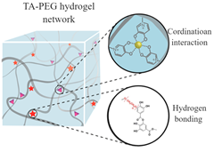Tissue adhesives are required to close wounds and stop bleeding efficiently; however, existing biomaterials are cytotoxic, expensive, and bond to tissues weakly. Synthesize of a compatible, and self-healable hydrogel through dynamic non-covalent bond with high mechanical strength and deformability is highly challenging. In this work, a polyethylene glycol (PEG) based hydrogel containing tannic acid-Fe (III) (TA-Fe) nanoparticles will be fabricated by an eco-friendly and straightforward strategy. The hydrogel will be formed through multiple dynamic non-covalent bonds between TA and PEG and between TA and Fe (III). These multiple dynamic bonding endow the hydrogel with high mechanical properties. The synthesized hydrogel will be able to exhibit high adhesive properties due to the presence of abundant dihydroxyphenyl and trihydroxyphenyl groups in the TA structure. The hydrogel will be tested for its mechanical properties, antibacterial activity, and cell biocompatibility. The hydrogel can become a promising antibacterial wound dressing for biomedical applications.  
* figure Adopted from Andersen et al 2018. DOI: 10.1021/acs.biomac.7b01249 Biomacromolecules 2018, 19, 1402−1409

###### Subject 2: **Investigation of the effect of tannic acid concentration and treatment time on the physicochemical and biological properties of hydrogels reinforced by cellulose nanocrystal**.

Developing hydrogels with advanced mechanical performance and multi-functionalities as alternative materials for load-bearing soft tissues remains a significant challenge. In this work, tannic acid (TA) will be exploited as a molecular coupling bridge between cellulose nanocrystals (CNC) and polyethylene glycol (PEG) chains for the fabrication of a bio-based advanced physical hydrogel via strong multiple H-bonds and hydrophobic interaction. By exposing to mechanical stress, the sacrificial H-bonds effectively dissipate energy on a molecular scale through dynamic breakage and reformation. This phenomenon will result in biomimetic hydrogels with high toughness and strength, significant elongation, and good self-recoverability superior to most of the hydrogen bond-based hydrogels. This project will investigate the effect of TA concentration and treatment time to develop a robust biocompatible hydrogel with suitable mechanical strength and functionalities for potential applications in tissue engineering.

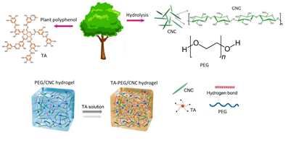

Adopted from Lin et al 2020.  
https://doi.org/10.1039/D0TB00424C, J. Mater. Chem. B, 2020

###### Subject 3: **Isolation and physicochemical properties of protein from insect farm side stream as a new source of bioactive molecules**

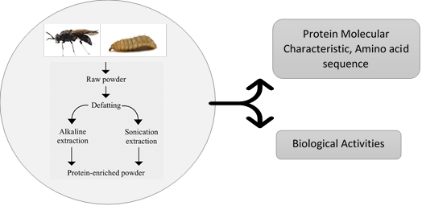Many insects naturally feed in organic wastes, converting biomass nutrients into their biomass and reducing the amount of waste material. Hermetia illucens Linnaeus 1758 (Diptera: Stratiomyidae), better known as black soldier fly (BSF), is one of the most critical species proposed as a converter of organic waste. BSF larvae can develop on a wide range of substrates, including agricultural by-products and organic waste. BSF is a good source of proteins, lipids, minerals, and chitin and has been proposed as a valuable source of animal feeds for different species such as fish, pigs, and chicken. This project is aimed to isolate protein from the side stream of an insect farm. The protein content of three different life stages of Black soldier fly BSF (Hermetia illucens), Adult Black Soldier Fly insect, Puparia, and Flake will be investigated. Chemical structure, the thermal stability of the extracted protein will be analyzed by FTIR spectroscopy and TGA, respectively. Besides, molecular weight and amino acid sequence will be investigated, as well as the antioxidant activity.

Subject 4: **Collagen extraction and characterization from mussel byssus and possible application as a wound healing patch.**

Mussel byssus is a by-product of mussel production and is a potential source of collagen. Mussel byssus mostly found in rocky intertidal, salt marsh, subtidal, and hydrothermal vents, which consist of a collagen fiber-reinforced composite that can withstand the wave forces. This project is aimed to extract collagen from mussel byssus by using the Deep eutectic solvents extraction method. The first objective of the project is to optimize the extraction parameters (the type of solvents and ratio, time, temperature, solid/liquid ratio) in order to 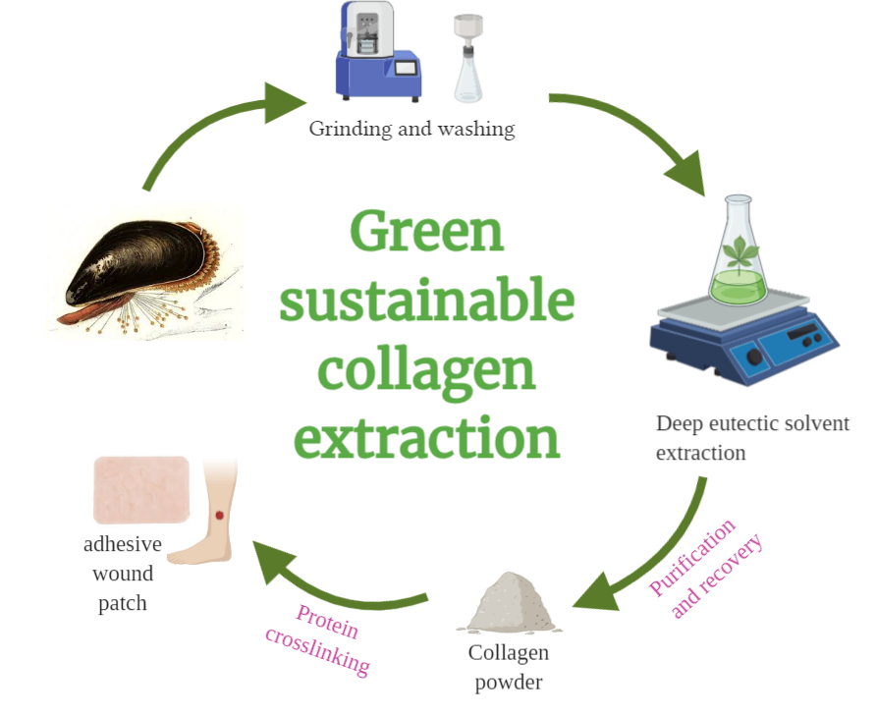obtain the highest collagen extraction yield. Besides, the wound healing application of the isolated collagen will be investigated through crosslinking the extracted collagen by the polyphenol chemistry as a green and sustainable protein binder. The chemical structure (FTIR analysis), thermal properties (DSC, TGA), molecular weight distribution (SDS-Page) of the extracted collagen will be investigated. Besides, the biological activities of the wound dressing patch will be evaluated through cell viability assay and antioxidant activity assay.

**PhotoBiocatalysis Unit BioCat- D. Cannella**[**www.photobiocatalysis.org**](http://www.photobiocatalysis.org)

**Projects description:**

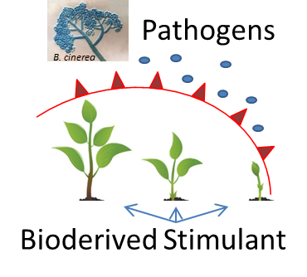**1) Biosynthesis of green plant stimulants and biopesticides for AgroBiotech  
Plant cell wall degradative enzymes** (CWDEs) are the arsenal used by pathogenic microorganisms (fungi) during their attack to plants. They represent a growing and continuous threats to crops and food production.  Us such the student will have to apply fungal-born enzymatic cocktail and measure the entity of plant cell wall degradation ex-vivo or in-vivo of plant subjected to a/biotic stresses. Key genes expressions as marker of plant immune system (molecular biology tech.), will be assessed so to predict the severity of the stresses applied. Moreover the plants will have to be evaluated to their increased or decreased susceptibility to pathogenic attack measuring secondary metabolites (HPLC and analytical chem techs), therefore hydroponic and standard cultivations will be studied (basic plant biology techs). The student will work together with an international team made of senior scientists and PhD students. The thesis will helps formulating general theories and trends of environmental and sustainability concerns for crops "bio"-productions, environmental bioremediations etc ...).

**Duration:** 8-9 months minimum or more  
**Techniques**: Plant cultivations and physiology, hydroponic, plant molecular biology, RT-PCR, Microarray, RNA-seq, HPLC, enzymes.  
**Supervision level**: D.Cannella, weekly email at [dcannell@ulb.ac.be](mailto:dcannell@ulb.ac.be)

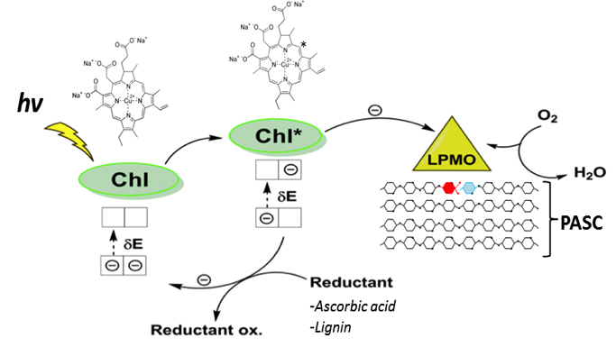**2) Enzymes evolution and engineering for photobiocatalysis&bioeconomy** ([Molecular biology – Biochemistry)](https://www.photobiocatalysis.org/master-thesis).

Worldwide the research in photobiocatalysis is focusing on applications of redox enzymes for the development of biorefineries based on lignocellulose resources. **Fungi** represents the natural sources of photo-excitable unique enzymes: LPMO, Laccase, SOD, peroxidases and new more are discovered constantly. Particular attention is dedicated at maximizing their activities which for redox enzymes means better electron donation, and research on LPMO enzymes elucidated some of its main characteristics, and possible way for its application.  In this project the student will investigate how to evolve and engineer Biomass-Active enzymes to increase their photocatalytic performances, substrate preferences stability and more. Also, will investigate stable heterologous expression, host selection to resemble industrial applications, purification and activity tests.

**Duration:** 6-9 months minimum or more  
**Techniques**: Molecular biology, plasmid assembly, PCR, RT-PCR, fungal-yeast-bacterial culturing, photo-biology, HPLC, purification via FPLC, rudiment of bioinformatics, structural biochemistry.  
**Supervision level**: D.Cannella, weekly email at [dcannell@ulb.ac.be](mailto:dcannell@ulb.ac.be)

**3) Biomass Transformation into BioPLAstic and Biofuels for Biorefineries**

The transformation of biomass into biofuels, bioplastics and bio-chemicals is today needed and it is already a robust reality at industrial scale. The today Bio-Engineers involved in circular economy is demanded to master the bio-transformation processes. In this project the student will have to transform the lignocellulosic biomass (or other alternatives) into a chosen commodity of her/his interest among: BioPLAstic, that is a Polymerized Lactic Acid molecule (PLA) to substitute petrol derived; BioFuels, in form of bio-ethanol; or BioChemicals in form of oligosaccharides for food implementation. The novelty of the project is guaranteed by the implementation of PhotoBiocatalysis processes via introducing physicochemical stimuli to the classical settings for carrying the enzymatic hydrolysis and fermentation of lignocellulose. The students will have to find the optimal parameters to increase the digestion of lignocellulose biomass and its consequent fermentation. The fine tuning of the settings will be carried from flask to progressively scale up to 2-20 lit volume pilot bioreactors. Finally fermentation of the biomass hydrolysate into a final desirable product will be performed using dedicated yeast and lactobacillus strains (bioethanol or bio-lactic acid for PLA or glycerol).

**Duration:** 6-9 months  
**Techniques**: bioreactor management, assembly, and design; photo-bio-catalysis, biomass chemistry, applied enzymology, HPLC, HPAEC-DA, fungal-yeast-bacterial culturing.   
**Supervision level**: D.Cannella, weekly email at [dcannell@ulb.ac.be](mailto:dcannell@ulb.ac.be)

**4)** [**Nano-Cellulose Biomaterials production**](https://www.photobiocatalysis.org/master-thesis) **– from Biomass to smart materials**

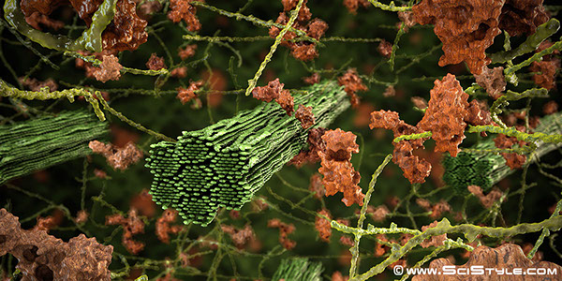Biomaterials are getting great interests for their versatile uses as composite materials, biomedical - hygiene products, food industry, packaging and smart-screens for TV and cellphones, and more. Nano-Cellulose and Nano-Fibrils (CNC and CNF) are considered the major and more applicable of these smart biomaterials, therefore research on bio-production and greener extraction is very active. In this project the student will have to investigate the transformation of raw biomasses from local (Bruxelloise) woods into NanoCellulose biomaterials using a green approach represented by enzymes to supplement the classic chemical-based processes. Moreover, characterization of physical property via microscopy, X-ray, FT-IR and more are envisioned. The student will have the choice to also fabricate the biomaterial for specific purpose of her/his preference, demonstrate the functionality in form of a small prototype: ex. Touch-sensible for Smart-screen, biocompatibility for use as patches, or enzymatic immobilization for bio-packaging.

**Duration:** 6-9 months  
**Techniques**: chemical-biochemical characterization of wood; reactor assembly for CNC production; TEM-SEM microscopy, X-ray, FT-IR, TCA etc. applied enzymology, HPLC.   
**Supervision level**: D.Cannella, weekly email at [dcannell@ulb.ac.be](mailto:dcannell@ulb.ac.be)