**Master Project Topics:**

**Biomass Transformation Lab - PhotoBioCatalysis Unit (D. Cannella lab)  
and Crop Production and Biostimulation Lab – Plant Biostimulation Unit**

**Emails**: [David.cannella@ulb.ac.be](mailto:David.cannella@ulb.ac.be)

**Projects description:**

**1) Biorefinery 2.0: Biosynthesis of plant vaccines and biopesticides for future Agriculture**

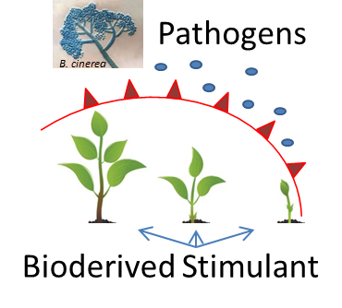**Plant cell wall degradative enzymes** (CWDEs) are the arsenal used by pathogenic microorganisms (fungi) during their attack to plants. They represent a growing and continuous threats to crops and food production. We recently discovered how to use such enzymes (including LPMO and other cellulases that will be produced during the thesis) to obtain plant vaccines based on specific oxidized oligosaccharides derived from the digestion of lignocellulose. The plants so treated will be investigated at genomic level for some key genes expressions as marker of plant immune system (DNA/RNA extraction, RT-QPCR, molecular biology technique), to predict the level of immunity stimulation, so being able at selecting the most promising among the several oligos. Moreover the plants will have to be evaluated also for their increased or decreased susceptibility to pathogenic attack after infections with pathogens, or measuring secondary metabolites (LC/MS, GC/MS, HPLC and other analytical chemistry techniques).   
The project can be tailored to the student personal interests and she/he will work together with an international team made of senior scientists and PhD students (having one as daily supervisor). The thesis is carried in the frame of an international EU project made of 13 partners (universities and companies), for which several meetings will be needed to attend

**Techniques**: Enzymes production, Lignocellulose digestion, plant cultivations and physiology, molecular biology RT-PCR, analytical chemistry LC/MS, GC/MS, HPLC.

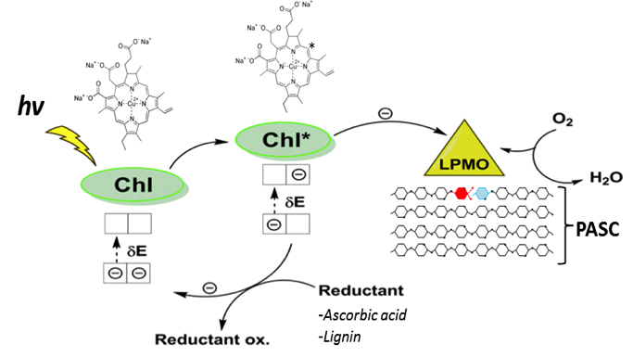**2) BioProcess design for photobiocatalysis of biomass**

Worldwide the research in photobiocatalysis is focusing on applications of redox enzymes for the development of biorefineries based on lignocellulose resources. **Fungi** represents the natural sources of photo-excitable unique enzymes: LPMO, Laccase, SOD, peroxidases and new more are discovered constantly. Particular attention is dedicated at maximizing their activities which for redox enzymes means better electron donation, and research on LPMO enzymes elucidated some of its main characteristics, and possible way for its application.  In this project the student will investigate how to evolve and engineer a Biomass-Active enzymes to increase their photocatalytic performances, substrate preferences stability and more. Also, will investigate stable heterologous expression, host selection to resemble industrial applications, purification and activity tests. This research is performed with the context of a PhD thesis with a dedicated daily supervisor that will set the experiments and follow the student regularly

**Techniques**: Biocatalysis, enzyme cloning and production, photobiochemistry, analytical chemistry HPLC, rudiment of bioinformatics, structural biochemistry.

**3) Enzyme evolution and Engineering for PhotoBiological removal of Green-House Gases**

Methane makes the most dangerous green-house gas in the atmosphere, as such its biological removal is one of the biggest environmental challenges for bioengineers. We recently discover how to set an enzyme based bioprocess to transform methane into methanol (biofuel), and in particular on activating this enzymes with light and waste biomass.   
The practical work will span from the enzyme engineering, its cloning and purification, until the setting of the actual biotechnology for the methane to methanol transformation. Elements of bioreactor design for improving the efficiency of the light-stimulated enzymes could also be investigated depending on the student personal interests.

This research is performed with the context of a PhD thesis with a dedicated daily supervisor that will set the experiments and follow the student regularly.

**Techniques**: Biocatalysis, enzyme cloning and production, photobiochemistry, analytical chemistry HPLC, rudiment of bioinformatics, structural biochemistry.

**4) Biomass Transformation into BioPLAstic and Biofuels for Biorefineries**

The transformation of biomass into biofuels, bioplastics and bio-chemicals is today needed and it is already a robust reality at industrial scale. The today Bio-Engineers involved in circular economy is demanded to master the bio-transformation processes. In this project the student will have to transform the lignocellulosic biomass (or other alternatives) into a chosen commodity of her/his interest among: BioPLAstic, that is a Polymerized Lactic Acid molecule (PLA) to substitute petrol derived; BioFuels, in form of bio-ethanol; or BioChemicals in form of oligosaccharides for food implementation. The novelty of the project is guaranteed by the implementation of PhotoBiocatalysis processes via introducing physicochemical stimuli to the classical settings for carrying the enzymatic hydrolysis and fermentation of lignocellulose. The students will have to find the optimal parameters to increase the digestion of lignocellulose biomass and its consequent fermentation. The fine tuning of the settings will be carried from flask to progressively scale up to 2-20 lit volume pilot bioreactors. Finally fermentation of the biomass hydrolysate into a final desirable product will be performed using dedicated yeast and lactobacillus strains (bioethanol or bio-lactic acid for PLA or glycerol).

**Techniques**: bioreactor management, assembly, and design; photo-bio-catalysis, biomass chemistry, applied enzymology, HPLC, HPAEC-PAD, fungal-yeast-bacterial culturing.

**5)** [**Nano-Cellulose Biomaterials production**](https://www.photobiocatalysis.org/master-thesis) **– from Biomass to smart materials**

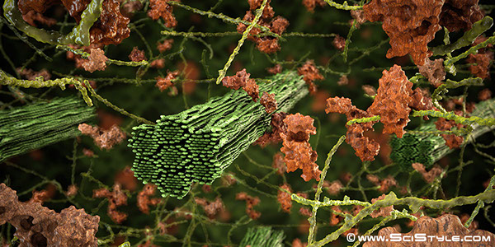Biomaterials are getting great interests for their versatile uses as composite materials, biomedical - hygiene products, food industry, packaging and smart-screens for TV and cellphones, and more. Nano-Cellulose and Nano-Fibrils (CNC and CNF) are considered the major and more applicable of these smart biomaterials, therefore research on bio-production and greener extraction is very active. In this project the student will have to investigate the transformation of raw biomasses from local (Bruxelloise) woods into NanoCellulose biomaterials using a green approach represented by enzymes to supplement the classic chemical-based processes. Moreover, characterization of physical property via microscopy, X-ray, FT-IR and more are envisioned. The student will have the choice to also fabricate the biomaterial for specific purpose of her/his preference, demonstrate the functionality in form of a small prototype: ex. Touch-sensible for Smart-screen, biocompatibility for use as patches, or enzymatic immobilization for bio-packaging.

**Duration:**   
**Techniques**: chemical-biochemical characterization of wood; reactor assembly for CNC production; TEM-SEM microscopy, X-ray, FT-IR, TCA etc. applied enzymology, HPLC.